
2026 SJHS Last Chance Meet
High School Cross Country
Wednesday, October 7th, 5:30 – 6:00 pm
Hosted by the Saint John High Cross Country Team




Co-Hosted by the Saint John Reds Track & Field Club & UNBSJ Cross Country/Track Team

Location: Wolatoq, Lancaster Avenue, West Saint John


Course Description: All events will take place on a well marked course around the perimeter of the park on a mix of grass and trail. This course is made up of a combination of 1.1 km providing a fast and challenging course. Thank you to J.D. Irving Limited for use of the park.

Registration Information: There is no registration fee but schools are encouraged to confirm attendance in advance at saintjohntrack@gmail.com . Individual and team entries are welcome. All athletes on a team must attend the same school and each team must have one adult in charge of check-in and recording. Registration will occur on site 3:30-4:00 pm. Athletes can walk the course up until 4:15 pm.

Parking: Limited parking is available in the park but overflow is available nearby.

Events: Participants are expected to meet at the start line just prior to race.
This event is being held after an Elementary school meet. High School races will follow immediately after.
Events will run in the order listed below, with the first race starting approximately between 4:45-5:00
Division Distance Course

High School – Senior & Junior Boys & Girls 3300m 3 x 1.1 km loop

For More Information: For More Information: SaintJohnTrack@gmail.com, Oy Akinola at 204-998-0743, Bill MacMackin at 506-647-4931

The park entrance is across from the Bowlarama, 248 Lancaster Ave.
Please avoid parking in the bowlarama parking area.

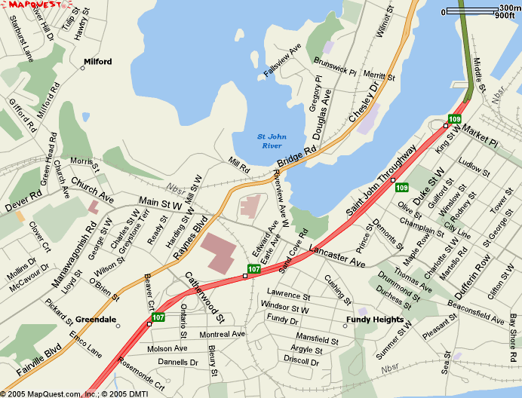

Race Courses

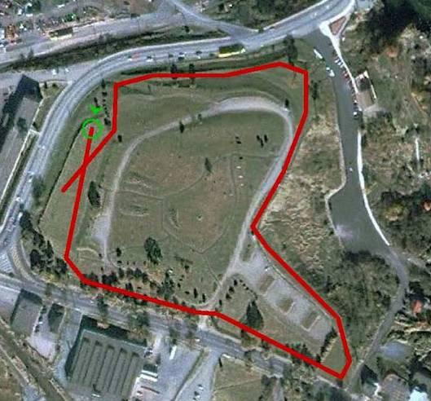
1.1 km Loop

